TEAM ID: PNT2022TMID39954

PROJECT NAME: DemandEst - AI powered Food Demand Forecaster

DHIVYA BHARATHI.V

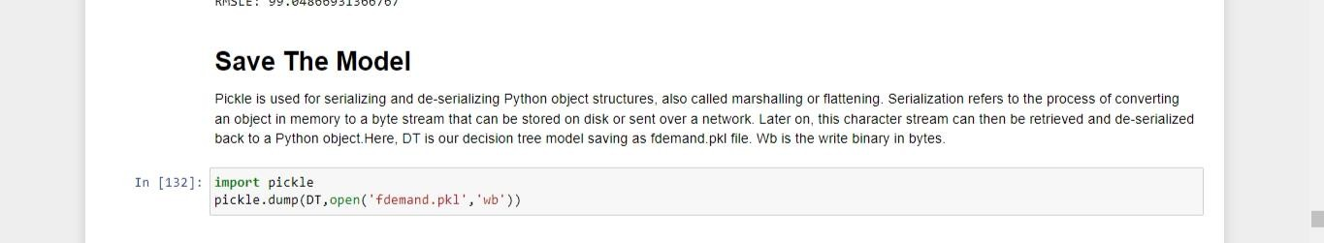

LAVANYA.M



MONIKA.K



SOWMIYA.R



SWETHA.G